**CREATE A NODEJS AND DEPLOY TO HEROKU**

**STEP 1: CREATE PACKAGE.JSON FILE**

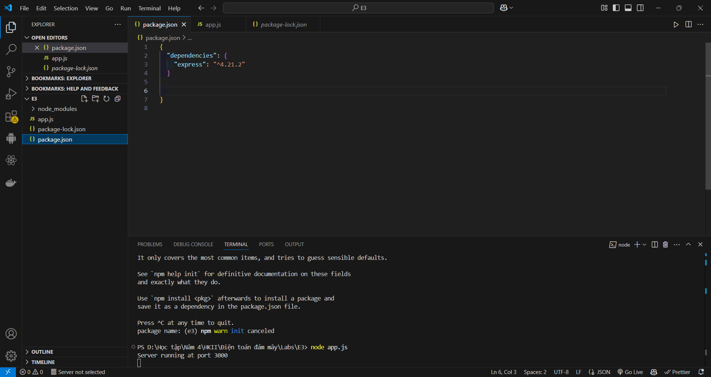

**STEP 2. ADD A FILE, APP.JS, AND PASTE THE BELOW CODE**

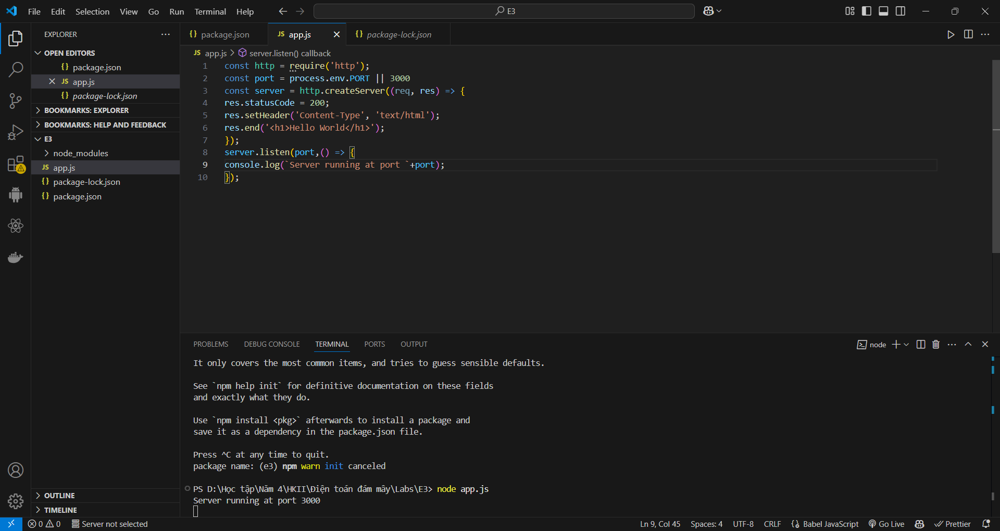

**STEP 3: PUSH TO GITHUB**

Go to Github and create a new repository like this

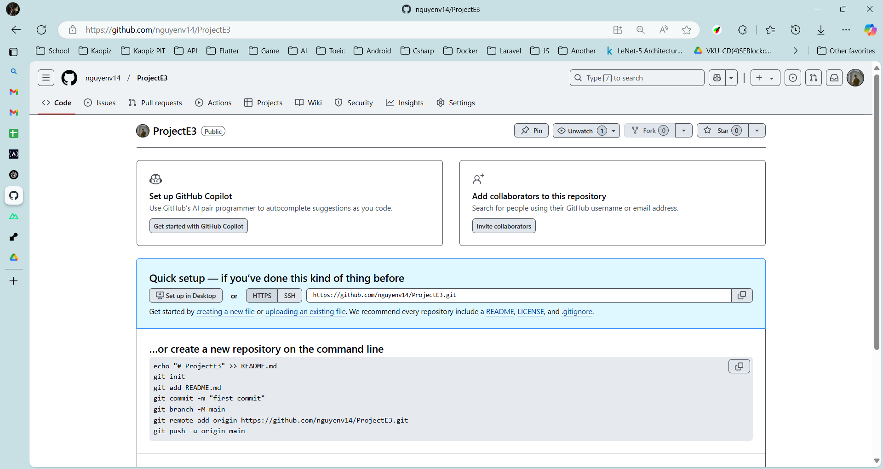

In the same path with app.js and type in the terminal

(Remember to replace your URL in remote address. Don’t use MyCoolNodeApp URI)

git init

git add .

git remote add origin https://github.com/rramname/MyCoolNodeApp.git

git push — set-upstream origin master

You should see messages like below at the command promp

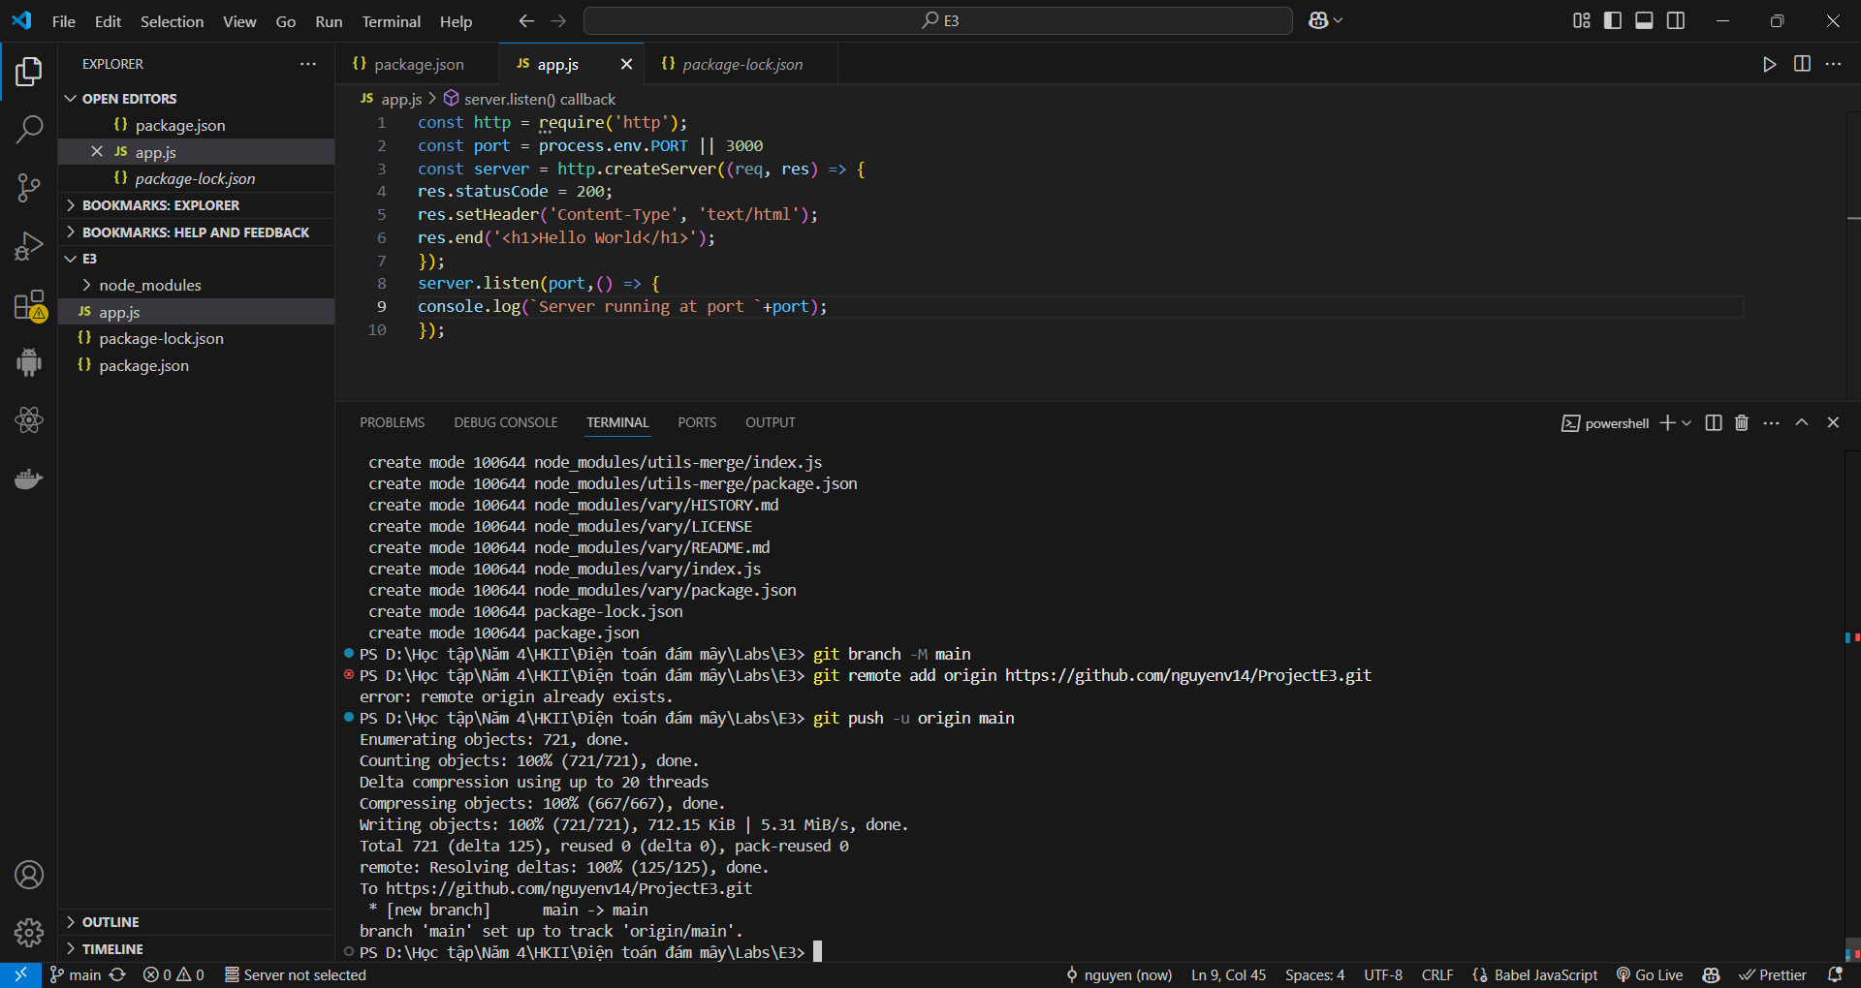

Now if you open GitHub and refresh the repository, you should be able to see the code.

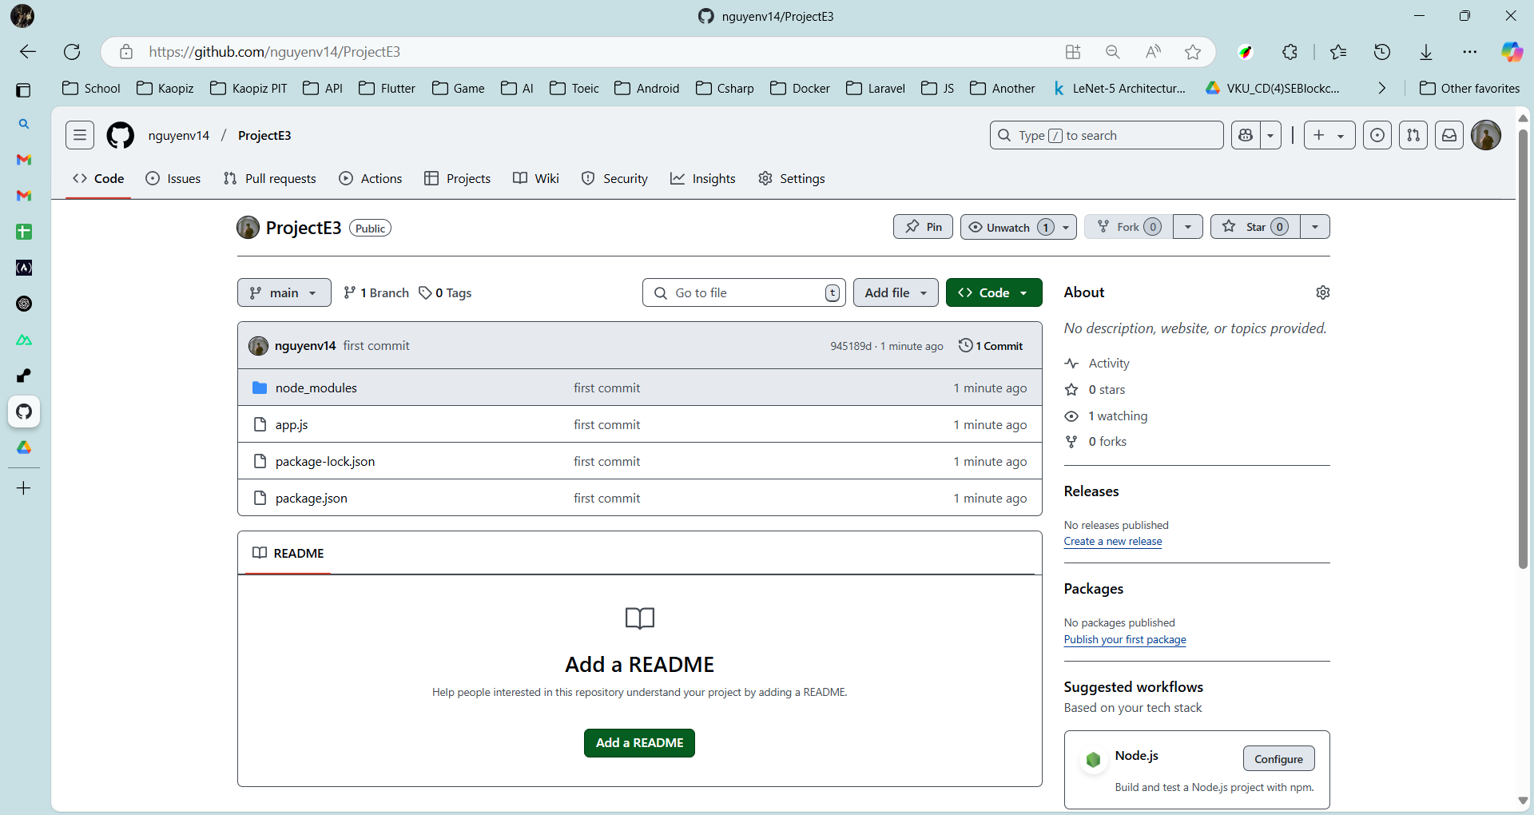

**STEP 4 DEPLOY TO RENDER**

